**Derived**

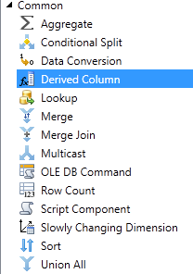

**1 NEW COLUM GrossAmount**



In Derived Column, you may add a new column or set which column you are replacing

**Column1**  = Upper( [ Column1] ) Type String (Replace)

**GossAmount**  = [Column3] + [ Column4] Type Unicode String (New)

**3 NEW COLUMNS**

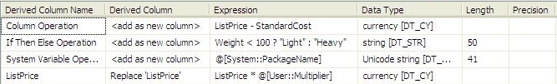

RIGHT([Column 9],1) == "-" **?** ((DT_NUMERIC,5,2)SUBSTRING([Column 9],1,10)) * -1 **:** (DT_NUMERIC,5,2)SUBSTRING([Column 9],1,10)

Let's break down the above statement into the standard **IF-Then-Else**.

**IF** RIGHT([Column9],1) == "-"

**THEN** ((DT_NUMERIC,5,2)SUBSTRING([Column 9],1,10)) * -1

**ELSE** (DT_NUMERIC,5,2)SUBSTRING([Column 9],1,10)



(DT_DBTIMESTAMP2,0)((DT_WSTR,4)SUBSTRING(RptMthDTM,1,4) + "-" +

(DT_WSTR,2)SUBSTRING((RptMthDTM,1,4) + "-" +

(DT_WSTR,2)SUBSTRING(RptMthDTM,5,2) + "-" + "01 00:00:00")

